Avantine IPOD OR DVD sound in Jack plug (please note this is only a sound or audio in only).
If you want to connect an IPOD/MP3 player or perhaps a portable DVD etc sound system to play through the standard Pioneer in car system then the following worked well for me.
It will not charge any device or be able to select option. Your only control from the car system is volume, the car display will only show Aux in play mode and volume if you adjust it.

Tools required
Torx bits T40 and T20
10mm spanner
Small soldering iron & solder
Phillips No1 screwdriver
Parts required
Three core wire ( length as required from under drivers seat to desired location)
3.5 mm stereo jack plug male
Two 22k ¼ or ½ watt resistors
Insulation tape

The following steps:
- Remove the drivers seat (RHD).
- Remove door weather seal at bottom edge
- Remove rear bench seat section
- Lift carpet and rubber lining
- Remove access panel to Pioneer amplifier
- Unbolt amplifier from floor
- Unplug all, radio, Display Cd, Infra red, speaker, power & remote plugs.
- Remove all screws that hold the case together on the box
- Carefully remove the circuit board (place it on a cotton cloth (avoid anything that might generate static)
- On the under side of the board locate resistor R449(left speaker) and R450(right speaker) see diagram
- Locate near by to these the circuit line called SGND ‘speaker ground’
- Take your three core wire, solder one to each resistor and one wire to the SGND (note which colour to which circuit) see picture
- With the two resistor wires you now can solder in line (series) a 22K ¼ or ½ watt resistor to each wire
- Insulate the cables from each other and then again from the rest of the unit (I used heat shrink but insulation tape may do )
- Reassemble the unit making sure the cable has a safe exit route from the casing, causing no compression of any internals and not at risk of getting damaged in any way
- Replace the unit in the car fully plugged in again) and route the new lead out under the carpet to where ever you want to place the input jack plug (mine is in the centre ash tray area as I don’t smoke)
- Refit cover, rubber, carpet, seats and weather strip as necessary
- Run cable to desired location
- Fit (solder) 3.5mm stereo jack plug to cables as picture shows
Job finished
To work system press Aux on your hand set then you can use the volume as necessary either at the steering wheel or via handset
Note that when you stop using your Ipod or MP3 that you have to switch it off yourself or it will continue to play even though your not using it and run its battery flat.

Jack plug has three terminals
Tip contact to Left speaker
Middle contact to Right speaker feed
Base or rear contact to speaker ground
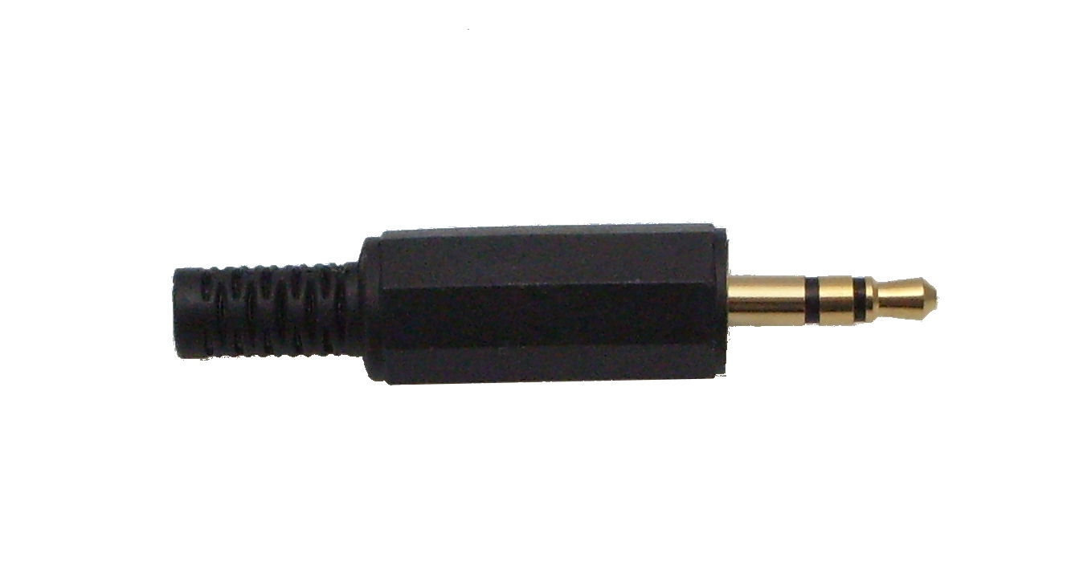
Shows connection to amplfier mother board.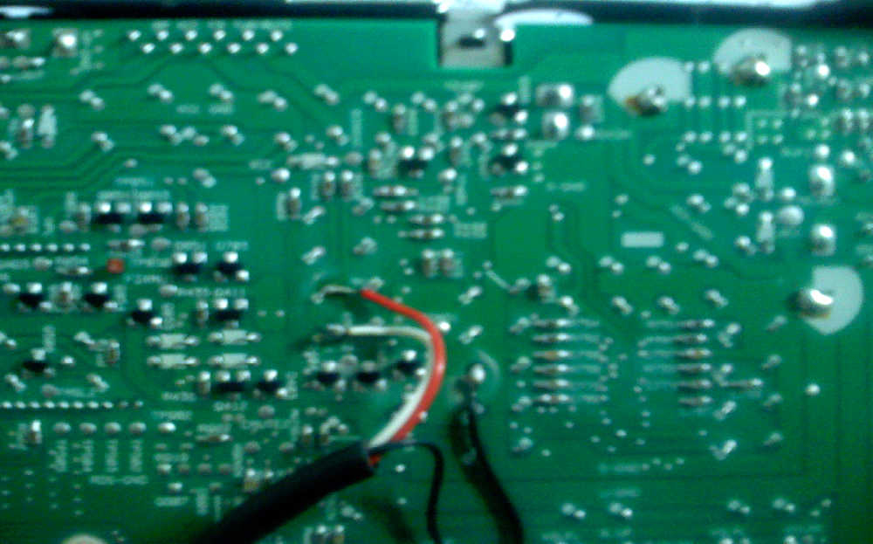

CIrcuit diagram below



